

Leeds Schools Cross Country League 2026-2027
Team Manager information.

Use the Racebest entry system to enter athletes.
The entry system is only for the use of Team Managers.
We will reject entries from anyone else.
The entry link for the first race is https://racebest.com/races/37u52
NB if you are entering additional athletes after the first race the link above will have expired but there will be a new link for each race, go to https://racebest.com/ and you’ll see all races listed by date.
The website shows an entry price of £50. At check-out please use discount code LSSA26.This will bring the price to zero.
Please only enter athletes who are very likely to run – last year over 270 entries didn’t run any races – at a cost of over £1080 to LSSA.
And please read this document before entering – there are some changes from last year and some useful tips in the section with the screenshots.
Entries for meeting 1 close on Wednesday 4th November 2026 at 5pm.
- All athletes must be registered and wearing a number which corresponds with this registration.
- Only the start times of the first race 10am for Primary Schools and 11:15am for High Schools is published. All other races will start as soon as officials are ready; high school races may be merged if number of athletes allows. All schools and athletes should allow enough time to park, register, familiarise themselves and athletes with the course, warm up and attend race briefing.
- Team Managers (TM) are school staff, or a responsible adult nominated by the Head teacher and if this is not a member of staff full information should be recorded on Evolve.
- TM must be clearly identifiable by wearing school branded clothing or an official school lanyard.
- TM must sign in leaving a mobile number at each meeting in the series. This is so we have a contact should any athletes become injured or there is an emergency.
- TM must collect race number bibs at Meeting one and, if they make additional entries between meetings, must collect additional race numbers at subsequent meetings
  - Race numbers (with black digits) have a timing chip and athlete details (school, athlete name, age group, medical conditions) on the back.
  - Race numbers are not transferable between athletes.
  - Race numbers from previous years (1 to 1341 and 2001- to 3357) must not be used.
- TM managers are responsible for ensuring athletes and spectators from their school follow the LSAA code of conduct.
- As athletes are representing their school the LSAA must have a School emergency contact mob number which will work on the day of the meeting. This is in addition to the nominated adult contact info. Entries will not be accepted without School emergency contact information.
- If, on the day of the meeting, the School Emergency Contact has changed, then the TM must notify this at registration
- Schools must complete their own Risk Assessment. A sample schools events Risk Assessment and a Cross Country risk assessment is available to download from Evolve. TM should have read and signed their schools Cross Country RA.
- It is strongly recommended that schools add LSAA Cross Country League to their extracurricular Evolve entry.
- Parking is limited at most this season’s venues. Please can schools maximise their efforts to reduce the number of vehicles attending by using minibuses, encouraging car sharing and having a transport plan in place.
- Please see LSSA website for details of events, course maps, results and info about possible postponement of meetings.
- Leeds School Sports Association provide the finance for all LSAA events. All schools must be affiliated to LSSA or Leeds Well Schools to take part in LSAA events. This can only be done by direct affiliation to the LSSA and not as a part of any SLA.
- Please complete the on line entry form https://racebest.com/races/37u52 for each athlete.
- If you have any further enquiries, please do not hesitate to contact Donna Riddler at rrd@princehenrys.co.uk
Special notes for High Schools
- Meeting two at The Clearings, Middleton Park will be this year’s Leeds Schools Cross Country team trials. The top 12 athletes in year 7/8 and 9/10 races will be selected to represent LSSA at the West Yorkshire Schools Championships.
- At the West Yorkshire Schools races, the top athletes will be selected to represent West Yorkshire – years 9/10 at the English Schools Championships and years 7/8 are likely to go to a new inter-county event in Leeds (details to follow).
- For the English Schools, there will be an additional cost which will be directed to the school via invoice, and the school can then decide how this is paid (School, Parent or Carer)
- If you have any athletes who are older than the normal age range for their school year (because they deferred entry to the primary school system or any other reason), you must record their actual dates of birth on the entry form for the LSSA series.
  - Over age athletes in school Year 8 who want to be considered for the Leeds team in the WY race must run in the year 9/10 race in the LSSA and have notified us of their choice before the event. Those not wanting to be considered should run in the year 7/8 race.
  - Over age athletes in school Year 10 may run in the year 9/10 race but won’t be considered for the Leeds team.
  - The over-age rule doesn’t apply to primary schools; they will run in their school year at all meetings.
Process for each meeting

- Only the TM may make entries.
- Online entries will close at 5pm on the Wednesday before the meeting.
- Those who enter online are automatically entered for all meetings.
- TM should bring 4 safety pins per athlete to the meeting.
- TM must collect race number bibs on the day for all athletes entered since the previous meeting
  - Race numbers for online entries have black digits on the back, a timing chip on the back and the athlete’s name, age group, school and medical conditions on the back
- There will be no entries to the series taken on the day, but those who have missed the -entry cut-off and want to run can be given guest number bibs (these will have red digits to distinguish them):
  - These may only be requested by TMs
  - TM must keep a record of who they have given each guest number to
  - TM must write the school, athlete’s name and medical conditions on the back of the guest number.
  - Guests will not be included in any results
- For safety reasons, no-one will be allowed to start the race unless they are wearing a race number bib (black number or red number).
- Athletes should not run in a bib that belongs to another athlete:
  - It would cause serious problems in an emergency
  - If in the same age group it would corrupt individual results
  - If in a different age group it would not record the result
- Race results will be published soon after the last race has finished on https://racebest.com/results.
- Consolidated race results (e.g. with school team totals for the race and series totals to date) will be published a few days later on the LSSA website.
- Online entries will re-open on the Monday after the meeting. (NB those who have already entered online must not enter again). There is a new link for each meeting, see https://racebest.com/races .
- Those who came as a late entry / guest to a meeting may enter online for the rest of the series and will be given a series race number at the next meeting.
- TM should do their best to ensure that athletes who have been given numbers bring their numbers to subsequent meetings, otherwise they or the parent will need to pay for replacement numbers at £4 each. TM may decide it is safer to collect in all the race numbers at the end of each meeting and re-distribute at the next meeting.
- Those who lose their series number must pay on the day of the next meeting for a replacement series number (they mustn’t enter online again).

Using the Racebest entry system to enter athletes

The entry link for the first race is https://racebest.com/races/37u52 .

NB if you are entering additional athletes after the first race the link above will have expired but there will be a new link for each race, go to https://racebest.com/ and you’ll see all races listed by date.

Note that the system will allow you to do a batch of entries and this will save time as some of the boxes will allow you to copy details from the first entry in the batch and other boxes may auto-fill if you start typing part of a name. However we recommend you don’t do more than about 10 in a batch because if there is a power failure or internet failure it could take a long time to re-enter.
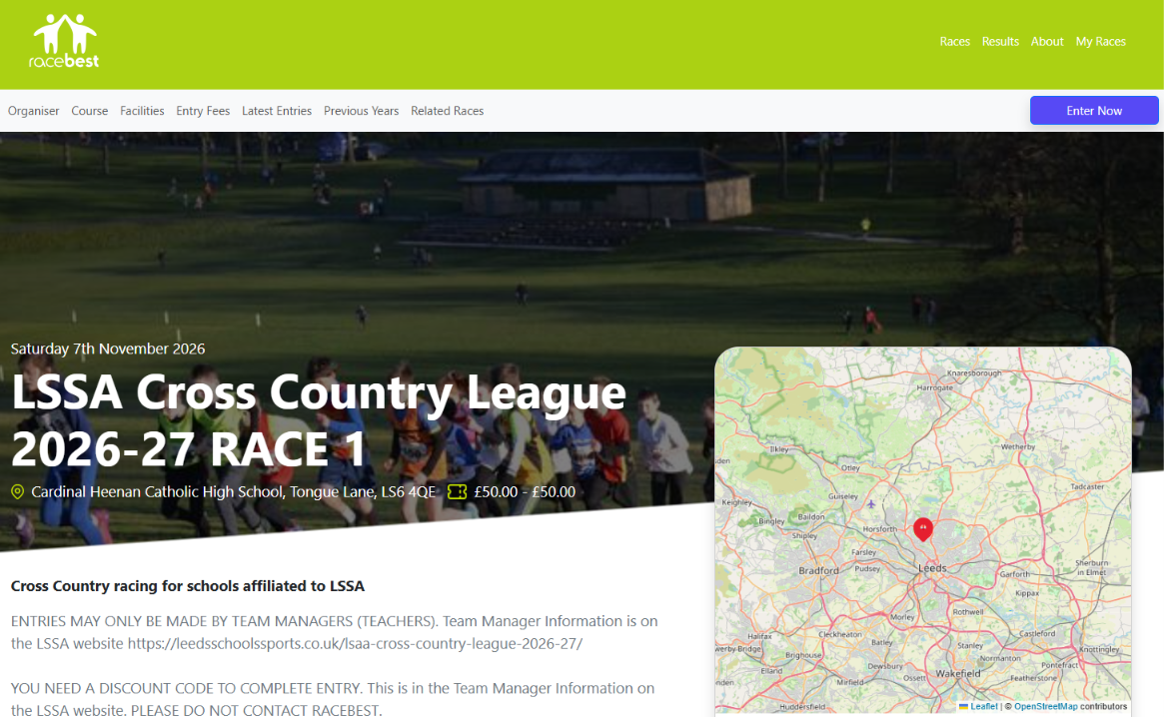

Click on the blue “Enter Now” button at top right of screen …

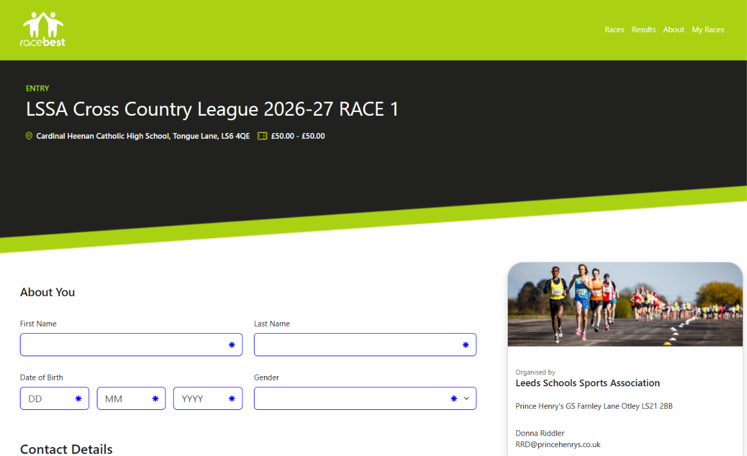
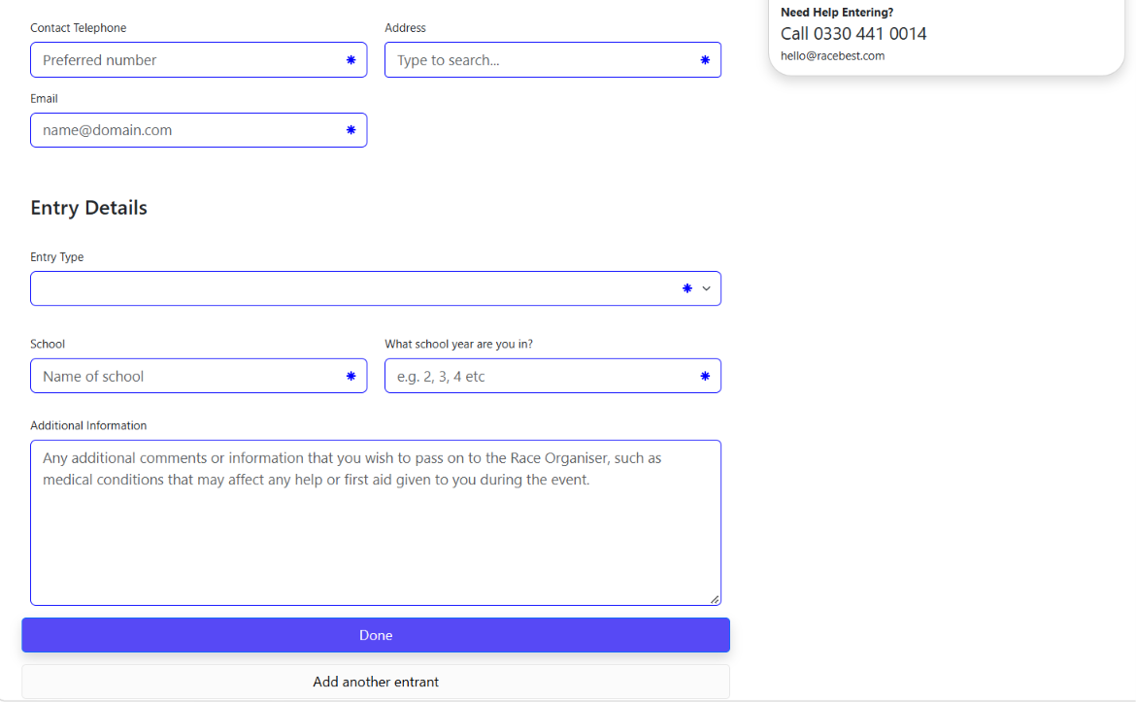

Fill in this screen – see next pages …
Fill in as follows
- First name – just put in an initial unless you have two athletes with the same surname and initial. (GDPR advice)
- Last name – use an alias if the athlete’s name mustn’t be published.
  - (please don’t use full first name and initial for last name, it is confusing)
- Date of birth – if you don’t know the date-of-birth it is OK just to input a date of birth that corresponds to the school year, we recommend that you put 1st January of the relevant year – to calculate this, subtract the school year from 2022 so school year 4 would be 01/01/2018. But ideally input the correct date-of-birth because we will then cross-check to school year in case of typing errors.
  - Please always use the correct date of birth for “over-age” children
- Contact telephone – Team Manager’s phone (not the athlete’s!)
- Email – TM’s email
- Address – school address - note that your web browser should remember this for subsequent entries

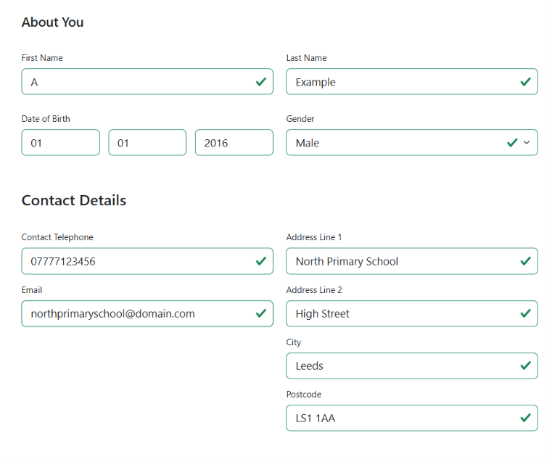

Continuation of same screen …

- Entry type – select “£50.00 Season Ticket”.
  - The race category says “School years 3-10”. Year 11 won’t be allowed to enter this year.
  - Entry type – note that it says £50 but you will have a discount code such that there will be nothing to pay in total.
- School name – please be consistent with the way you spell your school name. The Racebest team will sort your race numbers by athlete surname within school name, so if you spell your school name differently e.g. “St Bedes” / “St Bede’s” / “St.Bedes” or e.g. “Primary” / “Primary School” / “P.S.” then the race numbers won’t come to you in alphabetical order, and when we calculate team points they won’t be merged.
- Additional information – please include medical information. This will be printed on the back of the race number bib so in the event of emergency a first-aider on course can send information directly to the first aid support for the event.

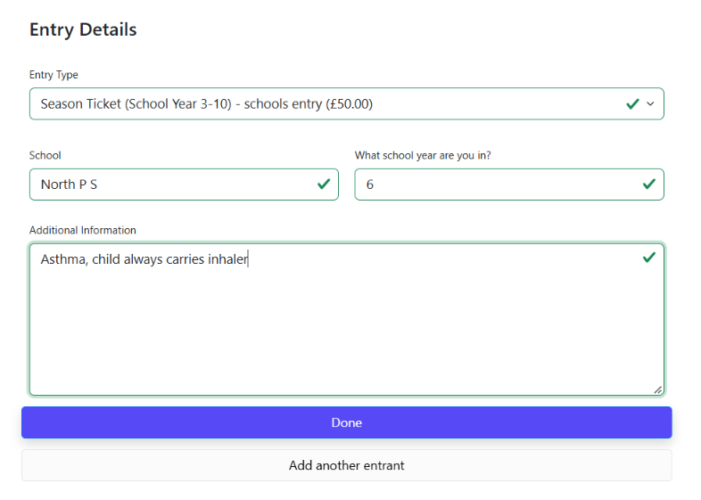

Then click on “Add Another Entrant” (or “Done” if you’ve only got one”) …

Next entrant …

*** Time-saving Tip – Click on the yellow “Copy My Details” button ***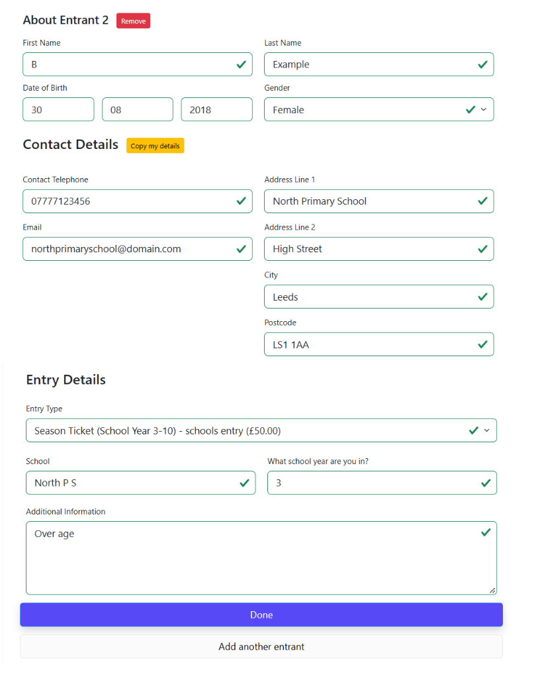Make sure you’ve spelt the school name identically
Then click “Done” (or “Add another entrant” if you’ve got more) …
Here’s the summary of your entries after you’ve clicked “Done”
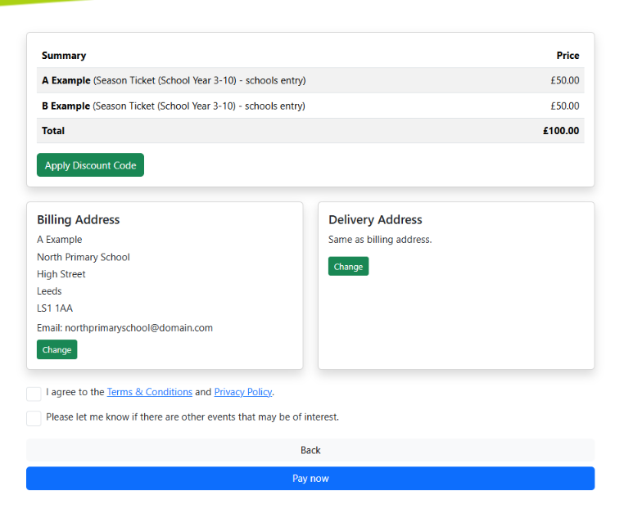

Click on the “Apply Discount” button (it’s just above “Delivery Address)

This will pop up…
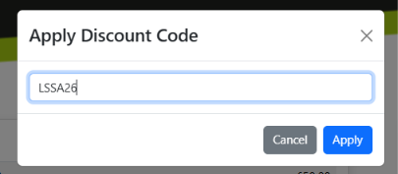

Input “LSSA26” (without the quotes) and click on the “Apply” button.

Then click on the “Pay Now” button at the bottom of the previous big screen
.
Price has changed to zero!

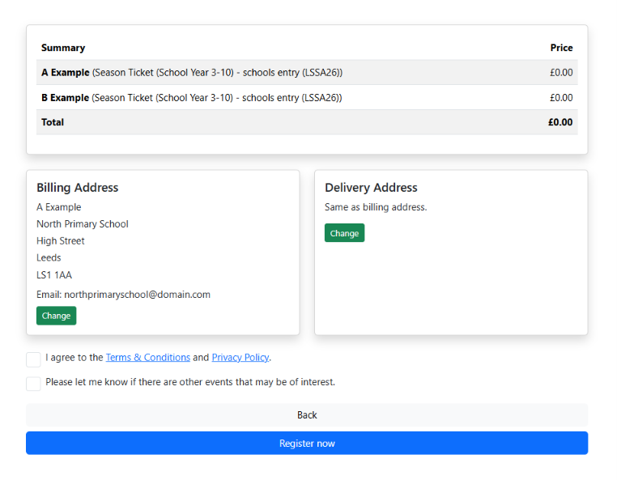

Click on the checkbox “I agree … etc”

Click on the “Register Now” button …

And you get a confirmation screen …

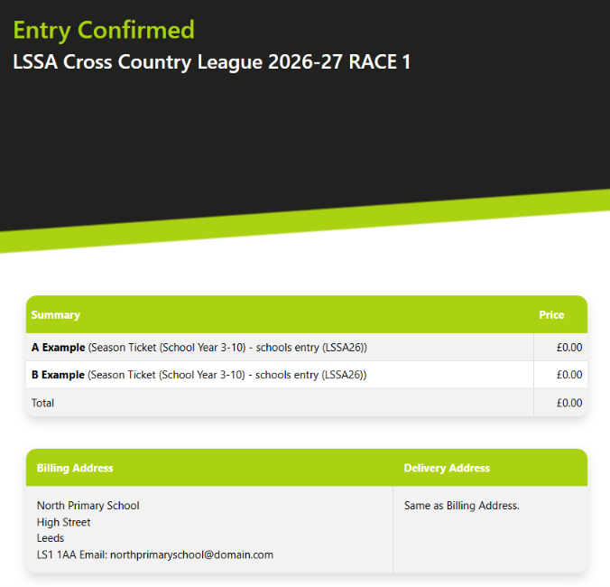

You’ll also be sent an email immediately to confirm this
If you don’t receive an email, then contact Bob Jackson at boblssaxc@gmail.com who will be dealing with any questions regarding the entry system. Please don’t contact Racebest for this.
It is important that we have the correct email for all Team Managers because we will send pre-race information for each race to these email addresses using an automated bulk email system within Racebest.

