Valley Striders Juniors – Annual Report 2025
Issued February 2026
Contents
Training groups 2
The “competitive” group (a.k.a. the “C” group) 2
Nicola Hartley’s group (a.k.a the Girls “A” group) 2
The Boys “A” group 3
The Main Groups 3
Training Attendances (all groups) 5
Training awards (all groups) 5
Membership numbers 6
Coaching and Leading 7
Coaching and Leading in 2026 7
Insurance and Safety 8
DBS checks, the DBS Update Service, Safeguarding and Welfare 8
Competition 9
Races 9
Parkruns 11
Schools Cross country 12
Awards 13
Participation Awards 13
Performance Awards 13
The “C” Group (from Richard Irvine) 14
The Girls 12-17 Group (from Nicola Hartley) 15
Accounts Analysis 16
Membership Fees 2026 17
Social 17
Communication and Feedback 17
More Thank Yous 18
Recruitment Summary 18

Training groups

The “competitive” group (a.k.a. the “C” group)
These are secondary school children competing in cross country and road running. This has almost become a separate group since mid 2024.
Their training cycle consists of an off-road hill session the 1st Tuesday of the month, a track session at Beckett Park the 2nd Tuesday, a tarmac session using part if the Brownlee Cycle Track the 3rd and final weeks and something different the 4th week of a 5-week month.
This group has three qualified coaches - Richard Irvine, Alex Gostling and Phillip Tedd (thank you!).
Most of the members of the group have come through from primary school and the transfer usually takes place in the spring of their last year at primary school so that they get training with the group before the next cross country season which is when they’ll then be eligible for county, regional and national competition. But in 2025 they recruited three 16 year old boys.
As at December 2025 there are 35 in this group and the average attendance for autumn 2025 has been 20.
There is more information about the competitive group in a separate section in this report, written by Richard Irvine.
The fact that the “competitive” group now never trains at Leos or GSAL has released capacity for the other groups.

Nicola Hartley’s group (a.k.a the Girls “A” group)
This is a group of older girls aged 12 to 17. 4 girls had joined prior to CoVid and several more secondary school girls have joined since then.
Although running mainly at Leos up to mid 2024, this became an almost autonomous group during 2025, with the girls joining the “C” group at Bodington for 2 sessions per month, and also running some sessions on the footpaths near Alwoodley Primary School, particularly for weeks where Leos was unsafe or “doubtful”.
The parents have a WhatsApp group and there are frequent parkrun tourism Saturdays. The average age is 14. It would be very rude to call this group “non-competitive” – many have run the Leeds 5k series at the Brownlee Centre, 2 or 3 have tried the West Yorks XC, and 1 has run the Abbey Dash.
Nicola has now nearly completed her LiRF (Leadership in Running and Fitness) course which will gives her England Athletics insurance to lead a group of ages 12 and above.
As at December 2025 there are 12 in this group and the average attendance for autumn 2025 has been 7.
There is more information about the Girls “A” group in a separate section in this report, written by Nicola.
The fact that the Girls “A” group now is more often training elsewhere than Leos or GSAL will release capacity for the other groups.

The Boys “A” group
This doesn’t exist; if it did it would be for a less competitive group of older boys aged 12 to 17. We’ll be putting plans together later this year for this!

The Main Groups
I’m not sure that this is the best title but they do comprise over 70% of our membership.
Note that there aren’t solid boundaries between the main groups and the “C” and Girls “A” groups. Quite often there will be a crossover of athletes, particularly to facilitate transport when two members of a family are at different locations or the timeslot of the “C” group doesn’t suit a family.
The Main Groups consist mainly of 6 to 12 year olds but also include some slightly less competitive members aged 13 and older.
In 2025 these groups trained at Leos from January to the end of June and from mid-September to December. In summer they were at Leos alternate weeks. There were 3 timeslots – 4:40, 5:25 and 6:10 – and most weeks there were 6 activities. Generally there were 3 or fewer groups (of up to 12 children) at each timeslot which allowed there to be no queues for each activity. Typical attendance was 65 to 70.
There were 8 weeks (3 in Jan/Feb, 5 in Nov/Dec) when Leos was unfit/unsafe to train and they trained on the cycle path that crosses Alwoodley Green from the little car park. For safety reasons we have a maximum of 18 children so 54 in total. From November we introduced 4 timeslots (4:40, 5:15, 5:50 and 6:25) which allows a maximum capacity of 72.
It had been planned that the main groups would train at GSAL on alternate weeks from mid-April to mid-September but there was a set back because GSAL had introduced new procedures that they required all volunteers to have enhanced DBS checks which were registered with the DBS Update Service. We negotiated with GSAL and they let us attend providing every activity had someone with these DBS checks. For more information about DBS, see the new section “DBS checks, the DBS Update Service, Safeguarding and Welfare”. We had 5 weeks at GSAL. The final week at GSAL was a “Sports Day” with medals for all competitors (88 attended including some from Girls “A”).
We have had have 4 special sessions.
On 15 July, training was cancelled and 93 (31 teams of 3) ran in the Golden Acre Relays.
On 9 September, 88 (including some from Girls A) took part in a sports day at GSAL. Gold medals were awarded to the best athlete in each age group, silver medals to those that had won an event in their age group and bronze medals to everyone else.
On 28 October, the juniors went to the Brownlee Cycle Track and 30 of them ran a timed mile race (one full lap of the track). Then 16 joined 40 adults for a 5k handicap race – the “Club Handicap”.
And on the morning of 27 December, 56 children and 40 parents ran in Santa hats round the lakes in Roundhay Park and then competed as 13 teams in “Café-Lake relays”. Many thanks to the parents who led and were back-markers for the 5 groups.
The main groups actually had 37 weeks at Leos.
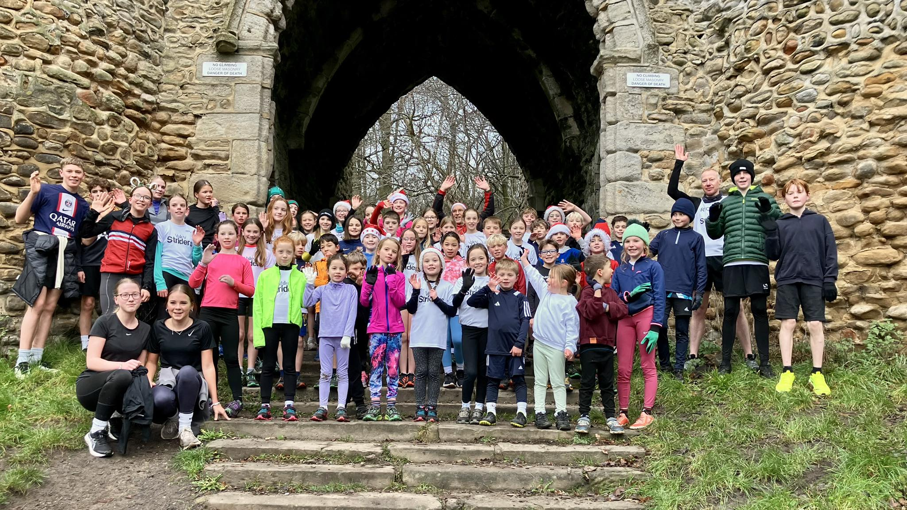

Training Attendances (all groups)
There was just one week when all training was cancelled due to snow and ice.
For the other 51 weeks we averaged 80 (this includes summer holidays and half terms where attendances were significantly lower)
On 25 February, attendance reached 100 for the first time and we had 5 other weeks of 100 or more.
Since our first junior session in 2012 we have had over 28,000 attendances.

Training awards (all groups)
All training counted towards attendance medals for 25 appearances (bronze), 50 (silver) and 100 (gold). During the year, we presented 16 gold, 35 silver and 38 bronze.
We present personalised plaques for attending 200 training sessions. Prior to 2025 there had been 4 recipients, in 2025 we awarded 6 more – to Joseph Whitehouse, Oliver Lubiecki, Ewan Reid, Bertie Bell, Mary Venning and Alice Bonner. And on 6 January 2026, Caitlyn Hartley received a bigger trophy for 300 attendances.
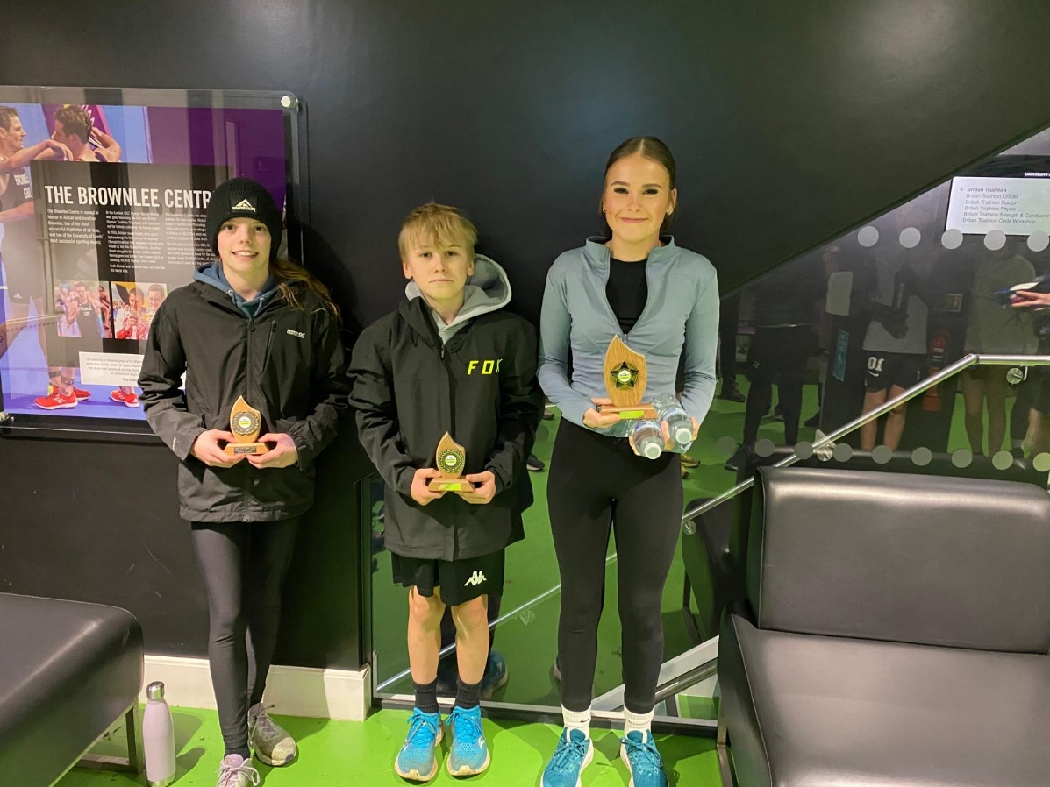

See https://www.valleystriders.org.uk/juniors/ for general information about our junior section

Membership numbers
Year by year | First claim | Not affiliated | Social (not training) | TOTAL JUNIORS | Volunteer parents
31 Aug 2018 | 16 | 83 | 0 | 99 | 0
31 Aug 2019 | 19 | 91 | 0 | 110 | 0
31 Dec 2020 | 7 | 84 | 2 | 93 | 0
31 Dec 2021 | 15 | 108 | 6 | 129 | 0
31 Dec 2022 | 17 | 113 | 17 | 147 | 0
31 Dec 2023 | 25 | 111 | 18 | 154 | 0
31 Dec 2024 | 28 | 143 | 12 | 183 | 0
31 Dec 2025 | 44 | 122 | 6 | 172 | 15

2025 tracker | First claim | Not affiliated | Social (not training) | TOTAL JUNIORS | Volunteer parents
31 Dec 2024 | 28 | 143 | 12 | 183 | 0
Resign | -6 | -35 | -6 | -47 | 0
1 Jan 2025 | 22 | 108 | 6 | 136 | 0
Change Out | -1 | -17 | -2 | -20 | 0
Renew | 21 | 91 | 4 | 116 | 0
Change In | 15 | 3 | 2 | 20 | 2
New | 8 | 28 | 0 | 36 | 13
31 Dec 2025 | 44 | 122 | 6 | 172 | 15

There has been a small drop in overall membership since last year. Several of these were juniors paying half price membership for less than 10 training sessions so the income from membership fees has only seen a small drop. The loss of 6 social members is relatively insignificant regarding income.
There has been a significant increase in the number of juniors who have paid affiliation to England Athletics. It is necessary for anyone competing at West Yorkshire XC (except U11), WY Track and Field (except U11) and higher level competitions which start at U13. It is very strongly encouraged for those competing in adult races such as Leeds 5k and Abbey Dash (minimum age 15) and, most significantly for Leeds 5k (minimum age 11). It was made compulsory for the Competitve group in 2025 and most have run a race requiring it in 2025.
A new category of membership, “Volunteer Parents” has been introduced for parents who have current DBS certificates which are registered on the DBS Update Service (this is described further in the Safeguarding section later).

Coaching and Leading
Prior to Covid, we used to have four groups turning up at 6pm and had four parents leading from a pool of 6 or 7 names .
Now we regularly have 9 main groups, each with 1 parent leading and 1 parent assisting. each group. For the younger groups, other parents act as “activity assistants” supervising slippery corners, hill running and backwards running at Leos. At GSAL there are also activity leaders and assistants for each activity e.g. starters, timekeepers, finish line judges, long jump measurers, shot putt technique demonstrators, shot put safety assistants.
It is marvellous that so many parents are actively involved and I’m sure that it doesn’t happen to this extent at many other clubs.
Richard Irvine, Alex Gostling and Phillip Tedd have continued to lead and coach the “C” group. All 3 are qualified Athletics Coaches.
Nicola Hartley leads the “Girls A” group and has a Leader in Running Fitness qualification. Because her group starts at age 12 she had extra components of her course – her video had to be of her group and include xxx and yyy, and she had extra safeguarding modules to do. Her second-in-command, Becky Baldaro-Booth is intending to do the same course.

Coaching and Leading in 2026
In 2026, we will be asking for some parents to do some courses. Courses available from England Athletics are https://www.englandathletics.org/coaches-and-officials/coaching-qualifications/
The Athletics Leader - two 90 minute online learning modules – is a good introduction to coaching juniors. The courses “up” from this - Coaching Assistant and Athletics Coach – are to lead athletes aged 8 and older but are aimed towards track and field clubs.
We are recommending that parents go on the Leader in Running Fitness course– it gives a licence to coach groups “on the road” of up to 12 athletes who are aged 12 or older. Most of our main groups aren’t that old and we don’t want to take them on the road but many of the principles are the same as for 12 year olds. What it will also do is allow us to set up older groups aged 12 and above and give them more variety, so retaining more members past 11.
The LiRF course includes taking a video of the applicant leading a group. We’ll have to borrow some 12 year olds from other groups for an evening!
Parents who want further qualification can then go on the Coach in Running Fitness course.

Insurance and Safety
Our insurance with England Athletics covers us for training sessions, led and managed by fully qualified coaches, for juniors aged 8 and above. Nicola’s LiRF qualification will cover training sessions for adults and juniors over 12 years old.
In 2024 we tightened up on some safety aspects during the year e.g. a signing-in form for parents not staying by the side of the field during the training sessions and e.g. making sure that when a child needs a loo-break that either the parent who brought them or two other adults supervise their trip.
This obviously left some gaps, and for that reason, in December 2024, we took out a second insurance policy. We are in the process of reviewing all aspects of training to ensure that we are covered by one (or both) of the insurance policies.
Asking more leaders to go on a LiRF course will give extra cover for locations and timeslots.
In spring, Tessa Freer took over the role of Junior Welfare Officer reporting to James Slater who is Club Welfare Officer. The Freers have recently moved to Ilkley so we have a vacancy again.
Note that the Welfare Officer doesn’t have to attend all sessions; far from it, their role is to check on safeguarding standards and mediate in safeguarding issues.

DBS checks, the DBS Update Service, Safeguarding and Welfare
The DBS Update Service was something that I and most of the club hadn’t heard of before GSAL made it a requirement for group leaders at their site.
DBS certificates are valid for 3 years but are effectively out of date as soon as they are issued.
When obtaining a DBS certificate there is an option to register it with the DBS Update Service. This means that future incidents relevant to the person are recorded. The person may then give permission for an employer to check the certificate.
But DBS certificates only prove that someone is safe with children; the certificates aren’t a qualification that can take a view on the safety of sessions. It would be useful for a few to go on safeguarding courses to be eyes at sessions to support our new welfare officer.

Competition

Races
2024 had finished on a high with the under 11 girls team winning their age category in the West Yorkshire Cross Country League. The team members were Niamh Archbold, Abigail Bottomley, Esmé Clark, Matilda Dark, Emmy Deverill, Dora Walmsley.
The 2024/25 Peco League had had three meetings late in 2024 and there were two more in early in 2025. 77 of our junior members took part in at least one race (72 in 2023-24) and average attendance was 46 (41 in 2023-24). 20 junior Striders ran all 5 races, qualifying for Peco mementoes. Within their age categories, Emmy Deverill was 2nd and Abigail Bottomley, Ella Shanks and Ruby Wilson all top 5.
In the 2025 Peco Relay we had 13 teams of 4. Abigail Bottomley, Dora Walmsley and Emmy Deverill won the Girls U11 and Ruby Wilson, Izzy Grosvenor and Ruby Wilson won Girls U9.
In higher level cross country (year 7 and above), 10 took part in the Yorkshire XC, 3 in Northern XC and 3 in National XC. (The Northern and National are both in our area in 2026 so hopefully we will have more representatives).
The Cross Challenge is a series of cross country races around the UK and Ireland for adults and juniors, for elite and county-standard athletes, and in February Temple Newsam hosted one of the rounds. Most of the events also hold “open” races and Temple Newsam did too, but forgot to do any publicity! 11 VS juniors entered and the 7 in the U11 races were nearly half of the competitors!
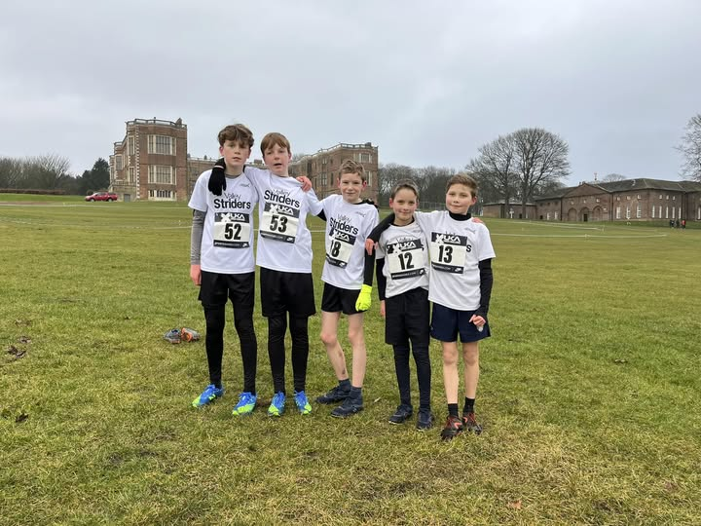
Two juniors, Indi Banerjee and Harry Richards, took part in the Wakefield Indoor meetings (50m, LJ, HJ, shot). Harry and Joshua Salmon competed indoors at EIS Sheffield which has a 200m track.
In the summer, 27 of our junior members took part in at least one track & field meeting. Harry Richards attended 9, Esmé Clark and Josh Salmon 6 each. 7 attended at one or more West Yorkshire T&F League meetings and 5 at one or more York meetings. By far the best attended were the two evening meetings at Beckett Park organised by Ian Richards (thank you) alongside the British Milers Club meeting. 22 attended one or both and hopefully many of these will feel confident to take part in the bigger meetings when the season restarts in April 2026.
NB Tilly O’Brien’s long jump of 4.89 at Beckett Park was the 6th best in the UK for 2025 by a U13 girl. Sadly she has chosen hockey as her main sport where she plays for Yorkshire.
In local races, there were 4 juniors at the Cookridge Community junior run (Niamh Archbold 1st girl), 4 at the Meanwood PTA race and 6 at the Ilkley Trail junior races.
23 junior Striders took part in the Eccup junior 1 and 2 mile races. In the 1 mile race, Josh Salmon was 1st , Emmy Deverill 2nd girl and Dora Walmsley 3rd girl. In the 2 mile race, Caitlyn Hartley was 2nd girl.
93 took part in the Golden Acre Relays. We had 23 teams in the races for school years 2 to 7 and had 8 junior teams (years 8-11) in the adult race in which the boys team of James Gostling, Will Thornhill and Jimmy Burns won their category, just ahead of last year’s winners (Conor, Joseph U and Sam). https://www.valleystriders.org.uk/golden-acre-relay-results-2025/
11 competed in the Golden Mile at Beckett Park in August. There was a new event at Beckett Park in September – the Tom Bosworth miles. Tom holds the world record for 1 mile race walk but fortunately this event also include running races. 7 Striders took part in the 1 mile run. Harry Richards ran a mile and race-walked a mile.
Moving forward to Autumn 2025, the cross country season restarted in October.
The first big event was the Northern Cross Country Relays at Sheffield where we had four teams of 3.
34 junior Striders took part in the West Yorkshire Cross Country League, far surpassing 2024’s record of 16. The U11 boys team won silver medals, the U11 girls and the U13 girls both won bronze and the U13 boys were just outside the medals, finishing 4th. Trophies were awarded to top-5 individuals Levi Woodger, Leo Freer and Emmy Deverill.
There were 2 Peco races before Xmas 2025 and one on 4 January 2026. 59 Striders have run at least one race so far.
Sadly there was no Abbey Dash junior race (17 had run last year)
In the 2025 Leeds 5K series of ten 5k races between February and November at the Brownlee Centre, 23 VS juniors competed in at least one race. Caitlyn Hartley and James Whittaker both ran 8 and Harry Durbin ran 7.
For more details of these and other races see
- https://www.valleystriders.org.uk/events-for-juniors-autumn-winter-2024-25
- https://www.valleystriders.org.uk/events-for-juniors-spring-summer-2025
- https://www.valleystriders.org.uk/events-for-juniors-autumn-winter-2025-26

Parkruns
In the first 47 weeks of 2025, 130 V S junior members (from a total of 170) ran 1202 parkruns including junior parkruns.
In September 2025 we introduced 2 “parkrun challenges” and we will have awards for every member who completes either before 31 August 2026:
- Run at least once at all of the 11 adult parkruns within Leeds city boundary
- Run at least twice at all of the 6 junior parkruns within Leeds city boundary

Schools Cross country
This Leeds Schools Cross Country League comprises 4 meetings on Saturday mornings and is for school years 3 to 10. Over 70 of our juniors took part in autumn 2024 and over 70 have taken part in the same series so far in Autumn 2025 (two meetings still to take place at time of writing). In the meeting in November there were special races for y7, y8-9 and y10-11, and from these, several club members were in the top 12 of a race and were selected to represent Leeds at the West Yorkshire Schools championships on 31 January 2026.
In both years a large percentage of our juniors in years 3 to 6 took part in a local round of the Leeds Primary Schools cross country Games. Top schools and top individuals qualify for the Leeds final on 4 February 2026 and from this, some qualify for the team to represent Leeds at the West Yorkshire Primary Schools event on 3 March and from this teams go to the National Primary Schools final. 19 Striders went to that event in 2025, some representing West Yorkshire and others as individuals.
These above sets of events are schools competitions but we hope that training at Valley Striders has helped their performances.
Club policy (if anyone asks) is, in the case of a clash of events on a day or weekend, that schools events take priority over club events except perhaps that a county or regional club competition should take priority over a minor schools event.
In the questionnaire for new members I ask for school name and also at the start of the school year I included a question in the training booking form for school name. Currently the highest representation in our membership are
- Primary schools: Gledhow 8, Roundhay PS 7, St Matthews (in Chapel Allerton) 6, GSAL PS 5, Roundhay St John 5, Thorner 5
- Secondary schools: Roundhay HS 32, Allerton Grange 13, Carr Manor 5, GSAL 5, Abbey Grange 4, Horsforth Horsforth 4
Interestingly (?), for the three schools most local to Leos, the numbers are St Paul’s PS 1, Alwoodley PS none, Allerton HS 1. Most of our recruitment is by word-of-mouth via current members but there is clearly scope for local recruitment too.

Awards

Participation Awards
We have two perpetual cups, one for a boy, one for a girl, which we present every 6 months for participation in training and at events. To qualify, members must have attended at least 13 training sessions and have taken part in at least 13 races/events (which may include parkruns) in the previous 6 months. The cups cannot be awarded again to previous winners.
Because there are not a huge number of competitive events, most of the previous winners have run a lot of parkruns (parkrun isn’t competitive is it?!).
September 2024 to February 2025 –
- Kirsten Reid
- James Whittaker
March 2025 to August 2025 –
- Dahlia and Dotty Mills (shared)
- Leo Robinson

Performance Awards
We purchase and award two trophies, one for a boy, one for a girl, every 6 months for the best age-graded performance in parkrun or junior parkrun.
We changed the rules in 2025 and the Best Performance Trophy MAY be awarded to a previous winner and in this situation there is a Performance Award to the best AG% for someone not a previous winner
September 2024 to February 2025 -
- Best boy – Levi Woodger
- Performance award – Elijah Tedd
- Best girl – Essie Molyneux
- Performance award – none – Essie was first time winner
March 2025 to August 2025
- Best boy – Sam Redmond
- Performance award – Ewan Reid
- Best girl - Essie Molyneux
- Performance award – Emmy Deverill

The “C” Group (from Richard Irvine)
“C" stands for competition. This group has been in existence for several years and represents those young athletes ages 11 – 18 who wish to continue competitive endurance running.
Numbers have grown over the past 12 months to 35. In Spring, Bob and I review the school year 6 athletes for potential new additions. Plus we receive a healthy number of external requests - teenagers already running competitively but without a club.
A number of our athletes are involved in other competitive activity, including regional and national level.
Our aim is to offer our athletes a more progressive and personalised session than they would receive in the "main" junior groups.
We have 4 qualified coaches, including Ian Richards who steps in as required. Plus we have a handful of parents who provide support.
At the start of each "season", we develop session plans that follow the annual race calendar (Yorkshire, regional and national events), according to age group.
We provide athletes with a session plan for independent training through the week and provide other ad hoc plans to develop core strength, etc.
In summer, we invited a nutritionist to speak to members of the “C” and “girls” groups. The session was designed specifically for teenagers and helped to reinforce positive diet and fuelling choices for developing athletes.
Outside of our Tuesday session, we have also organised a handful of Saturday sessions for athletes involved in specific competitive events.
Training venues each month:
- Leeds Beckett.
- 2 x the Brownlee Centre, sharing the circuit with the UoLXC Club (and recently Abbey Runners juniors).
- Hill session - this has taken place at Parkside Road (Smithy Mills), Lidgett Lane (former Allerton Grange HS site) and the Brownlee Centre (grass slopes behind the main building).
Most of all, we aim for our sessions to be fun and we feel privileged to have such a great group of committed young adults and supportive parents.

The Girls 12-17 Group (from Nicola Hartley)
Over the past 12 months, the girls’ running group had continued to show remarkable commitment and enthusiasm. Throughout the year, they have consistently attended and represented the group at Even Splits events, PECO Cross Country races, and weekly parkruns.
We have had a number of girls in the group who have been members of the group and attended sessions for a while, who have now taken part in events for the first time. In particular Mia Somerville took part in the Eccup 2 mile course last summer and also attended her first PECO at West Park this month.
It has been inspiring to watch their confidence, fitness, and camaraderie grow as they support one another and remain engaged week after week, regardless of weather, distance, or terrain.
The group is now training regularly with the C group for 2 weeks of a 4 week training cycle and embedding this has increased the fitness and confidence across the group.
The aim for the next 12 months is to assist some of the older girls with increasing their distance in preparation to be eligible to take part in road 10km races by offering a further social run over the weekend for those who may wish to attend.
Another fantastic year of running from the girls and a huge thank you once again to all of the parents who regularly show up to help, encourage and participate week after week.

Accounts Analysis
Item | 2022/23 | 2023/24 | 2024/25 | Explanation of change in 2024 /25 from 2023/24 | Forecast 2025/26 | Explanation
INCOME
Membership fees received | 4337 | 5080 | 5778 | Increase in members | 6000
Memb. cashbacks - race fees paid by member in prev yr | -309 | -538 | -620 | Peco races, Eccup Jun Race and a few others capped at 50% of memb fee | -1000 | Peco, Eccup, and many others
Membership Discount 10% | -275 | 0 | 0 | All via calc of races from 2023/24 | 0 | Discounts now all via race fees
Donation from Peco League | 150 | 150 | 100 |  | 0 | Not supporting race in 2026
Bank interest | 24 | 44 | 57 |  | 60 | Figure from Mick
TOTAL INCOME | 3927 | 4736 | 5315 |  | 5030
EXPENDITURE
Leos hire of fields etc | 2000 | 2000 | 2000 | 50% of total. Adults £1500 & M’wood trail £500 | 2500 | Upped juniors share because adults using less
GSAL hire of athletics track | 346 | 348 | 209 | Booked for 2 hours x 5 weeks (11 in 2024) | 500 | 12 sessions planned
Brownlee hire of circuit | 60 | 0 | 0 | 2 sessions in summer in 2023 | 120 | 1 session Oct 2025, 2 more for 2026
England Athletics club affil | 43 | 57 | 59 | Juniors share of £200 club fee | 70
Races paid for by the club in current year | 390 | 248 | 288 | Only G.Acre Relays in 2025, all other events paid by members and refunded in memb fee in 2026 | 350 | Ditto and also includes Northern XC Relays October 2025
Awards - 25/50/100 medals, Annual awards | 396 | 308 | 411 | Attendance medals and engraving of cups and trophies | 500 | Also add new parkrun tourist awards
Sports day trophies/medals | 272 | 36 | 150 | Medals for all participants in Sep2024 | 191 | Sports day was held 9 Sept 2025
T&F and other Equipment | 66 | 0 | 0 |  | 100 | Lights for Alwoodley Cycle Track session
Nutrition workshop | 0 | 0 | 0 |  | 300 | £150 for one in Sept 2025, allow for one more
Website | 57 | 18 | 9 | New website 2022/23 | 10
Shirts and vests expenses | 29 | 125 | -36 | Building up stock | 0
Coach/Leader/First Aid courses | 0 | 0 | 160 | 1 LiRF course | 900 | 4 LiRF Courses, 4 Safeguarding courses
DBS certificates | 0 | 0 | 260 | Requested by GSAL | 200 | Extra to ensure cover for all groups
Insurance | 0 | 0 | 135 | New; additional to EA | 134
Miscellaneous | 9 | -19 | 0 | Donation | 0
TOTAL COSTS | 3668 | 3121 | 3645 |  | 5875
PROFIT/ LOSS | 259 | 1615 | 1670 |  | -845
The above doesn’t include anything where we collect money from the member and hand on the same money to the supplier e.g. England Athletics affiliation for individual members, race entry fees that are paid by members to us because we have to enter the teams as a club and payment for vests and T-shirts where we pay the supplier the same value

Membership Fees 2026
Please see https://www.valleystriders.org.uk/junior-membership-renewals-rates-and-cashbacks-january-2026/

Social
I’ll just copy what I wrote last year … and the year before … unfortunately nothing has changed.
A disadvantage of the 3 timeslots is that sometimes I feel we are three separate clubs in that those at any one timeslot have only met those in the other two at the Sports Day at GSAL, the 1 mile and 5k event we had at the Brownlee Centre, the Xmas and at events such as Peco and Golden Acre Relay.
I hope we can reintroduce hot food at Leos after training. We would have to have 3 timeslots for this too, but actually this would make it more manageable for the catering staff – when we used to have just one session it used to take a long time to serve a queue of 40.
The Xmas runs in Roundhay Park are well-attended every year whatever the weather.

Communication and Feedback
We use Surveymonkey for parents to book sessions for their children a month at a time.
Each week, we use the website to list the juniors invited to attend each session.
We have a Facebook Group for parents to confirm attendance at training sessions, to announce and allow discussion of arrangements for events (e.g. Peco, WYXC), for photos of events and presentations, and for advertising lost property which we’re attempting to return.
We also have a Facebook Group set up for parents who have volunteered to lead groups. I will revive this soon as part of the Insurance and Safety Review.
The website is also used to publicise events and record results. The juniors section of the website has been reviewed in the last 3 months and updated as needed.
I would welcome any other feedback for improvements – please email the juniors@valleystriders.org.uk email address.

More Thank Yous
Thank you to
Head junior coach Richard – we don’t meet often as his 6pm group is never at Leos but frequently have chats in the evenings to plan what we’re going to do next. I look after the spreadsheets and Facebook while he looks after the coaching.
To Alex Gostling for developing training plans for the older juniors who train with us (each week she sends out a suggested session for Thursday evening).
To Phillip Tedd and Ian Richards – coaching the “C” group.
To Nic Hartley – leading the Girls 12-17 group at training sessions and other excursions
To Paul Furness – who has again travelled from Boroughbridge to support more than 5 sessions at GSAL this summer. Paul has also been a field events judge in the West Yorkshire T&F League for the last 6 years, enabling us to satisfy the condition of entry to the league that every club must provide 2 volunteers. He also voluintees at Yorkshire XC and some schools events.
To James Slater, our club Lead Welfare Officer – who has taken over responsibility while we recruit a new one or two.
To the families Clark, Deverill, Steere, Venning and others who have brought the club gazebo to the Peco Races (every time I put the posts in the car to go to GSAL or to an event my wife tells me I should have bought a van, I don’t know what she’d say if the gazebo was in the back!)
And, finally, a huge thank you (again) to ALL the parents who have helped at the sessions on Tuesdays.

Recruitment Summary
1 Junior Welfare Officer (and ideally another later in the year)
4 Safeguarding Courses
4 LiRF courses to get a view how E A expect leaders to work, to get ideas for other activities and to enable older groups to have sessions aways from Leos (NB the LiRF course also has a Safeguarding module)
10 more DBS certifications for leaders at GSAL

